PROJECT DOCUMENTATION
Machine Learning
Predictive Models for Network Request Prioritization & Risk Scoring
PROJECT
Automated Network Request Management

Date
Team ID
Project Name | Automated Network Request Management
Maximum Marks | 10 Marks

1. Introduction
Automating network request management in ServiceNow enhances operational efficiency by streamlining workflows, reducing manual interventions, and ensuring real-time updates. Machine Learning (ML) is used within this project to move beyond static, rule-based automation and enable data-driven decisions — such as predicting request priority, forecasting SLA breach risk, and detecting unusual configuration changes — so the workflow can scale intelligently as request volume grows.

2. Objective
- Predict the correct priority and category for incoming network requests using historical ticket data.
- Estimate the probability of SLA breach so at-risk requests can be proactively escalated.
- Score requests for auto-approval eligibility based on risk of change failure.
- Detect anomalies in configuration item (CI) changes that may indicate errors or unauthorized modifications.

3. Machine Learning Pipeline
Data is sourced from ServiceNow tables — including request history, CMDB records, and change outcomes — and passed through a standard ML pipeline: feature engineering, model training, validation, and deployment via Integration Hub as a callable prediction API within the Flow Designer workflow.
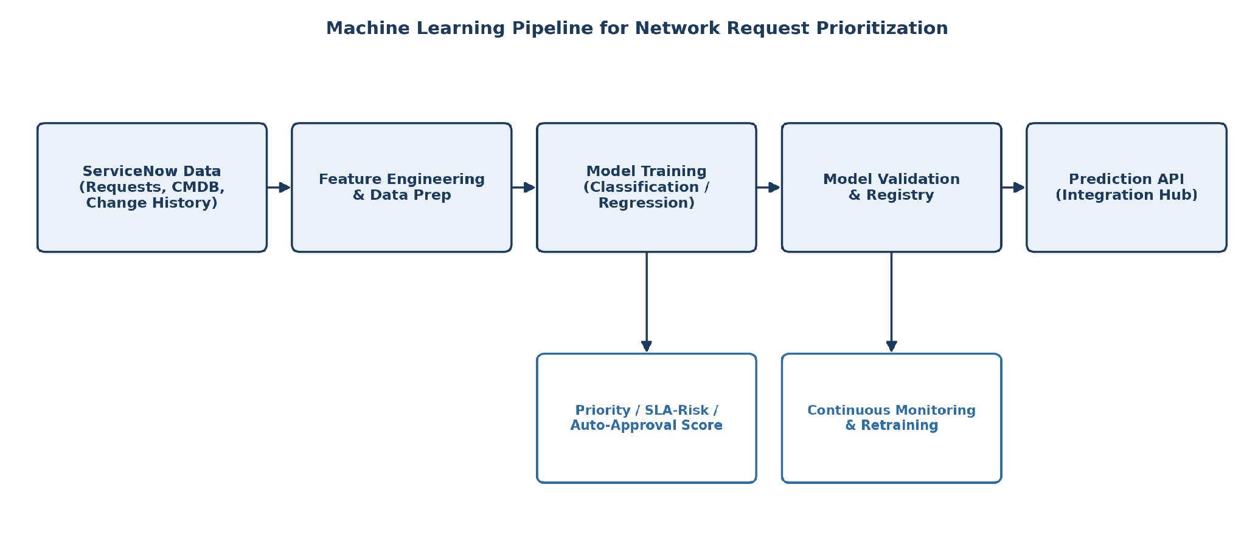
Figure 1: Machine learning pipeline for network request prioritization

4. Models Used
Use Case | Model Type | Input Features
Request category & priority prediction | Multi-class classification (Gradient Boosted Trees) | Request text, requester group, historical category patterns
SLA breach risk | Binary classification (Logistic Regression / XGBoost) | Current queue load, request complexity, past fulfillment time
Auto-approval risk score | Regression / risk scoring model | CI change history, past failure rate, blast radius of the CI
CMDB anomaly detection | Unsupervised anomaly detection (Isolation Forest) | CI attribute change patterns, frequency, deviation from baseline

5. Model Lifecycle

5.1 Training
Models are trained on historical ServiceNow request and change data, with periodic retraining as new labeled outcomes (approved, rejected, breached SLA, failed change) become available.

5.2 Validation
Each model is validated against a held-out test set using standard metrics (accuracy, precision/recall for classification; RMSE for regression) before being registered for deployment.

5.3 Deployment
Validated models are exposed as a prediction API and invoked from ServiceNow Flow Designer via Integration Hub, allowing predictions to be embedded directly into the request fulfillment workflow.

5.4 Monitoring & Retraining
Prediction accuracy and drift are monitored over time; models are retrained when performance degrades or when the mix of request types shifts significantly.

6. How ML Supports the Project Goals
Project Goal | ML Contribution
Rapid fulfillment | Correctly prioritized requests are routed and actioned faster
Audit-ready change records | Risk scores and model decisions are logged for every automated approval
Accurate configuration tracking | Anomaly detection flags unexpected CI changes for review
Scalability | Models generalize across growing request volume without added manual effort

7. Conclusion
Machine learning enables the Automated Network Request Management workflow to make consistent, data-driven decisions on prioritization, risk, and anomaly detection. This reduces manual review effort, improves the speed and reliability of fulfillment, and strengthens the audit trail required for network change governance.

